**Netflix Movies & TV Shows Data Analysis (SQL Project)**

*A Comprehensive SQL-Based Exploration of Netflix Content*

**Introduction**  
This project focuses on analysing Netflix’s movies and TV shows dataset using SQL.  
The goal is to extract key insights regarding content distribution, most common ratings, release trends, top-performing countries, and more.  
This report includes query results with visuals for all 15 business problems.

**Q1. Count the Number of Movies vs TV Shows**

**Objective:** Determine how many movies and TV shows are available on Netflix.  
**SQL Query:**

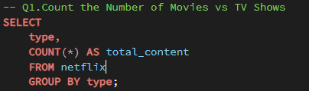

**Output:**

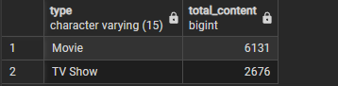

**Q2. Find the Most Common Rating for Movies and TV Shows**

**Objective:** Identify the most frequently occurring rating for each type of content.

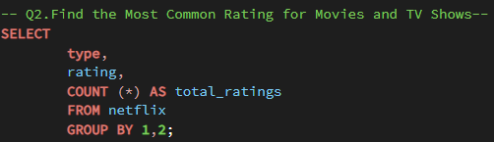**Query:**

**OUTPUT:**

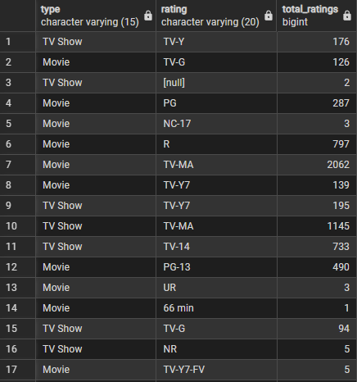

**Q3. List All Movies Released in a Specific Year (2020)**

**Objective:** Retrieve all movies released in the year 2020.

**Query:**

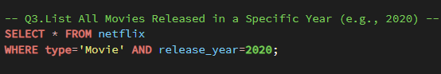

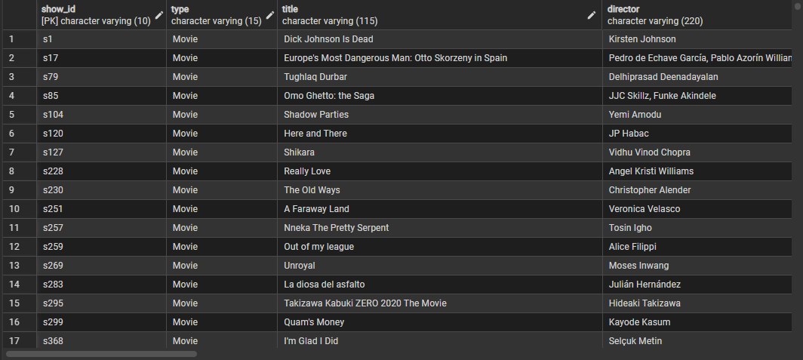**OUTPUT**:

**Q4. Top 5 Countries with the Most Content**

**Objective:** Identify the top 5 countries with the highest content count.

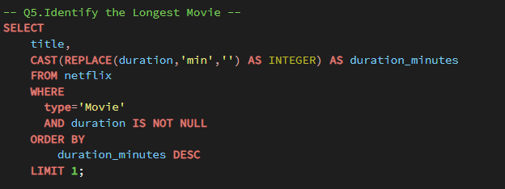**Query:**

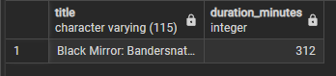**OUTPUT:**

**Q5. Identify the Longest Movie**

**Objective:** Find the movie with the longest duration.

**Query:**



**OUTPUT:**



**Q6. Find Content Added in the Last 5 Years**

**Objective:** Retrieve content added to Netflix within the last 5 years.

**Query:**

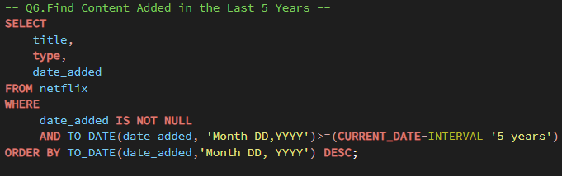

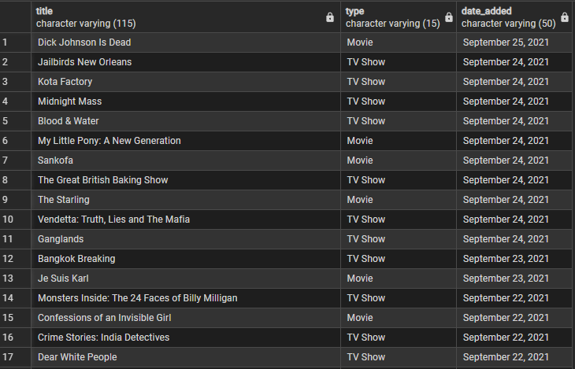**OUTPUT:**

**Q7. Find All Movies/TV Shows by Director ‘Rajiv Chilaka’**

**Objective:** List all content directed by ‘Rajiv Chilaka’.

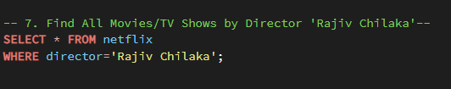**Query:**

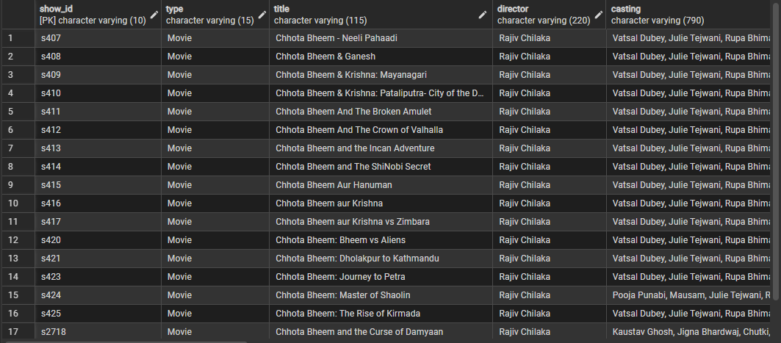**OUTPUT:**

**Q8. List All TV Shows with More Than 5 Seasons**

**Objective:** Identify all TV shows that have more than 5 seasons.

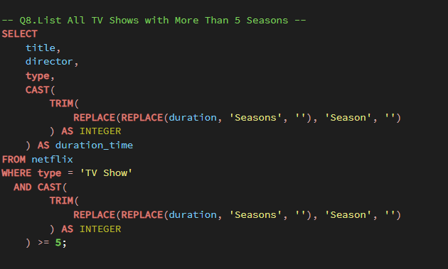**Query:**

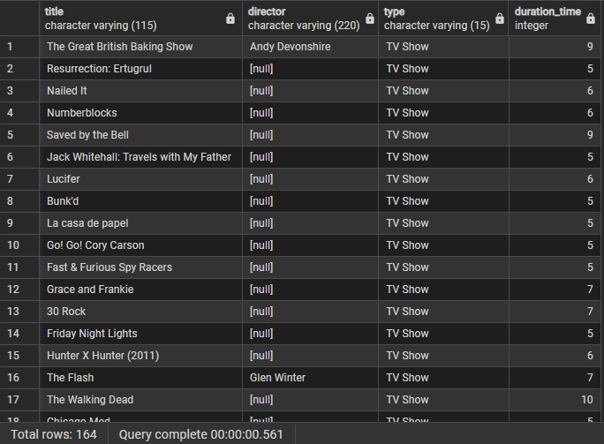**OUTPUT:**

**Q9. Count the Number of Content Items in Each Genre**

**Objective:** Count the number of items in each genre category.

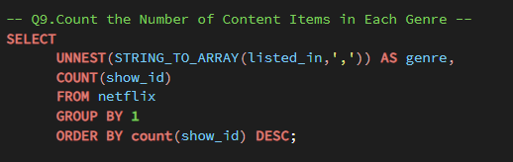 **Query:**

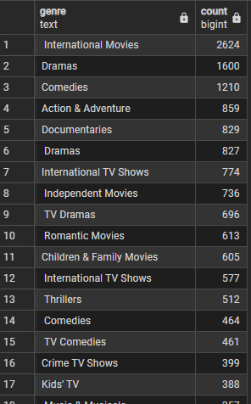**OUTPUT:**

**10. Find Top 5 Years with Highest Average Content Released in India**

**Objective:** Calculate and rank years by average content releases from India.

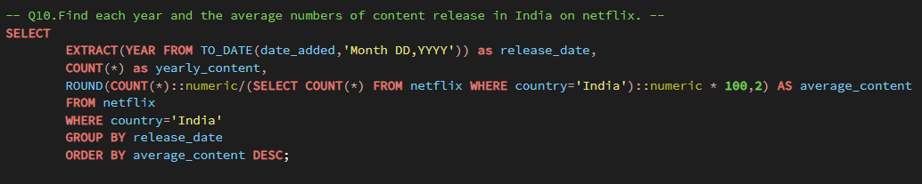**Query:**

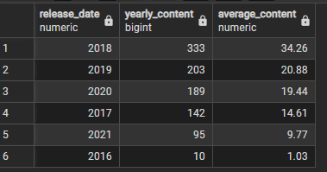**OUTPUT:**

**Q11. List All Movies that are Documentaries**

**Objective:** Retrieve all movies categorized as documentaries.

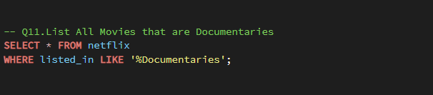**Query:**

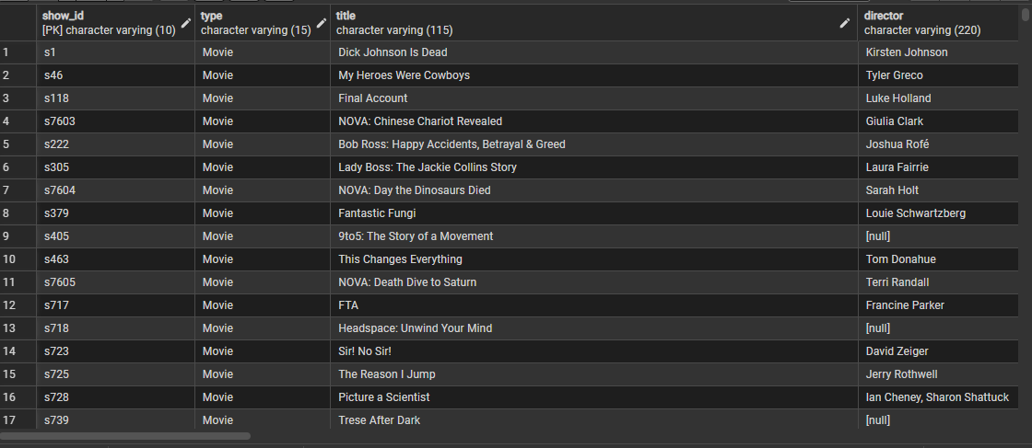**OUTPUT:**

**Q12. Find All Content Without a Director**

**Objective:** Identify content entries missing director information.

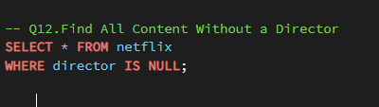**Query:**

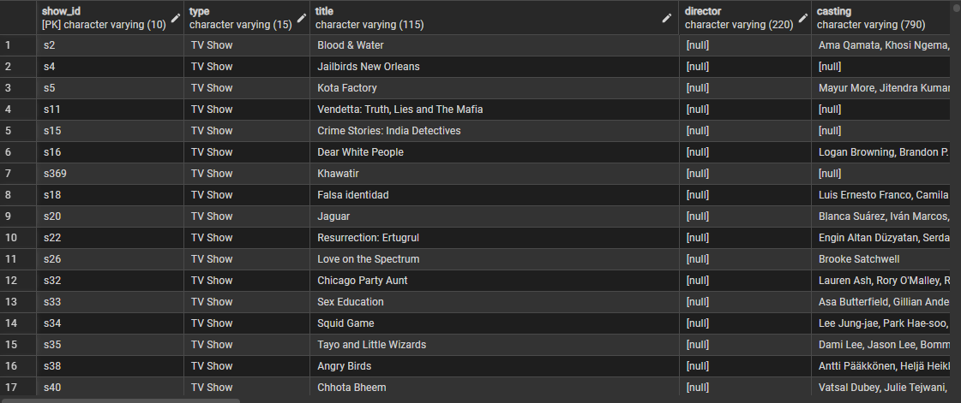**OUTPUT:**

**Q13. Movies Featuring ‘Salman Khan’ in the Last 10 Years**

**Objective:** Count movies featuring ‘Salman Khan’ released in the last decade.

**Query:**

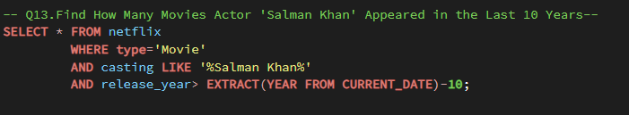

**OUTPUT:**

**Q14. Top 10 Indian Actors by Number of Movies**

**Objective:** Identify actors with the most movie appearances in Indian produced films.

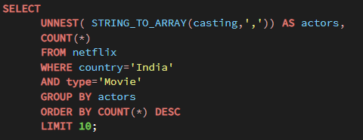 **Query:**

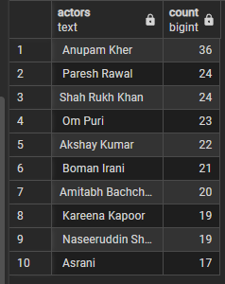**OUTPUT:**

**Q15. Categorize Content Based on Keywords ‘Kill’ and ‘Violence’**

**Objective:** Categorize and count ‘Good’ vs ‘Bad’ content usingkeyword analysis.

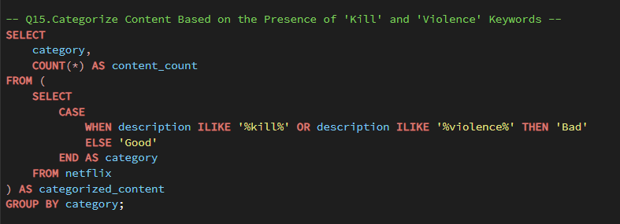 **Query:**

**OUTPUT:**

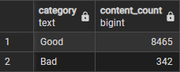

**NOTE**

This project provided valuable insights into Netflix’s content trends using SQL. By applying queries involving aggregation, filtering, string functions and window functions, I explored various aspects such as content type distribution, country wise releases, ratings and keyword based categorization. The analysis strengthened my SQL proficiency and showcased how data driven insights can support strategic decisions in the entertainment industry.